**Project Design Phase-II**

**Data Flow Diagram & User Stories**

|  |  |
| --- | --- |
| Date | 24 June 2025 |
| Team ID | LTVIP2025TMID29498 |
| Project Name | Asset Management Portal using Service Now |
| Mentor Name | Dr Shaik Salma Begum |
| Maximum Marks | 4 Marks |

**Data Flow Diagrams:**

A Data Flow Diagram (DFD) is a traditional visual representation of the information flows within a system. A neat and clear DFD can depict the right amount of the system requirement graphically. It shows how data enters and leaves the system, what changes the information, and where data is stored.

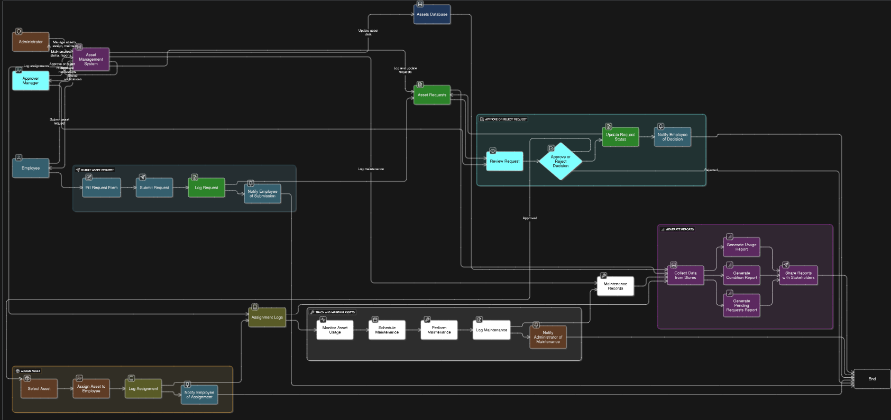

**User Stories**

Use the below template to list all the user stories for the product.

| **User Type** | **Functional Requirement (Epic)** | **User Story Number** | **User Story / Task** | **Acceptance criteria** | **Priority** | **Release** |
| --- | --- | --- | --- | --- | --- | --- |
| Employee | PDI Setup | USN-1 | As a developer, I can set up a Personal Developer Instance | Instance is active and accessible for configuration | High | Sprint-1 |
| Employee | Update Set Creation | USN-2 | As a developer, I can create and activate an update set | Update set is active and tracking changes | High | Sprint-1 |
| Admin | Table Creation | USN-3 | As a developer, I can create a Asset table with auto-numbering and form | Table is created, records have MFE prefix numbers | High | Sprint-1 |
| Admin | Table Creation | USN-4 | As a developer, I can create a Asset request table with auto-numbering and form | Table is created, records have DFE prefix numbers | High | Sprint-1 |
| Admin | Relationship Configuration | USN-5 | As a developer, I can I can link Assets to Requests and Assignments | Related list shows correct linked Daily Expenses in Family form | High | Sprint-2 |
| Admin | Workflow Automation | USN-6 | As a developer, I can configure workflows for approvals and notifications | Approvals and alerts work on submission and status change | High | Sprint-2 |
| Employee | |  | | --- | | Asset Request |  |  | | --- | |  | | USN-7 | As an employee, I can request an asset via a self-service form | Request submitted and visible to admin | High | Sprint-2 |
| Admin | |  | | --- | | Maintenance  Scheduling |  |  | | --- | |  | | USN-8 | |  | | --- | |  |  |  | | --- | | As an admin, I can log and schedule  asset maintenance activities | | Logs captured and alerts triggered for next service | Medium | Sprint-3 |
| Admin | |  | | --- | | Asset  Reporting |  |  | | --- | |  | | USN-9 | As an admin, I can view asset utilization and status reports | Reports display current asset count and condition | Medium | Sprint-3 |